World Geography

Final Exam

Review

2017



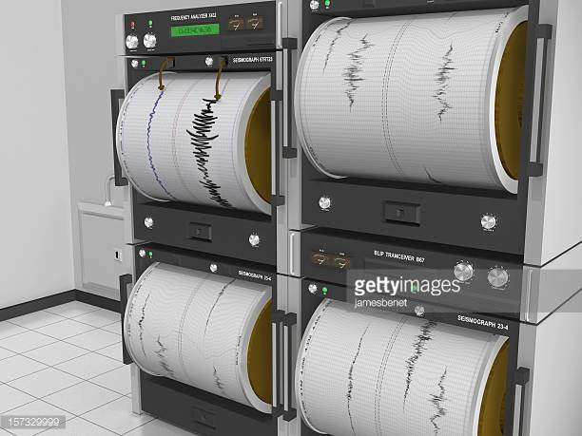

1. Discuss the relation between human- environment observe in the above two photos.
2. The global diffusion of advanced computer technology has caused access to:

________________________________________________________________________________________________________________________________________________________________________________________________________________________________________________________________________________________________________________________

1. Jerusalem

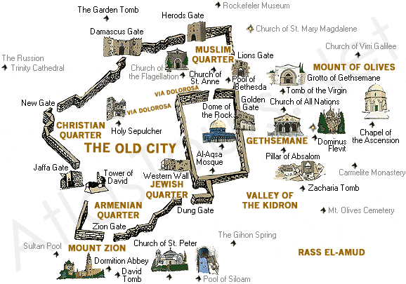

How many different worship places can you identify in Jerusalem? What might be the consequence of this religious diversity at this City?

1. Define the following terms related to immigrant:
   1. assimilate
   2. forced to settle
   3. customs
   4. quotas
2. Describe the different between Coniferous Trees and Evergreen Trees.
3. Define diffusion and provide 2 examples.
4. What is the main purpose of the Organization of Petroleum Exporting Countries (OPEC)?
5. Compare democracy with constitutional monarchy. List some countries with constitutional monarchy type of government.
6. Describe the 4 levels of economic activities: Primary, secondary, tertiary, quaternary.
7. What landscapes would you expect to see on a city that experience a large expansion of international trade?

The United States

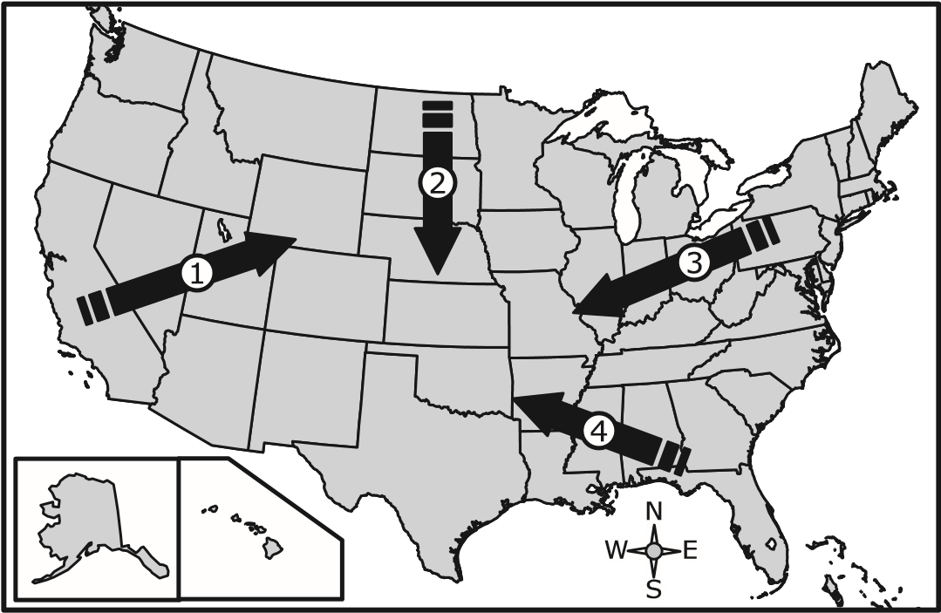

1. The above map shows different migration routes in the last century on the United States. Describe each arrow pull and push factors.
2. Many Europeans move to New York City in the mid-nineteenth century, what are the push and pull factors.

Spread of the Black Death, 1347–1351

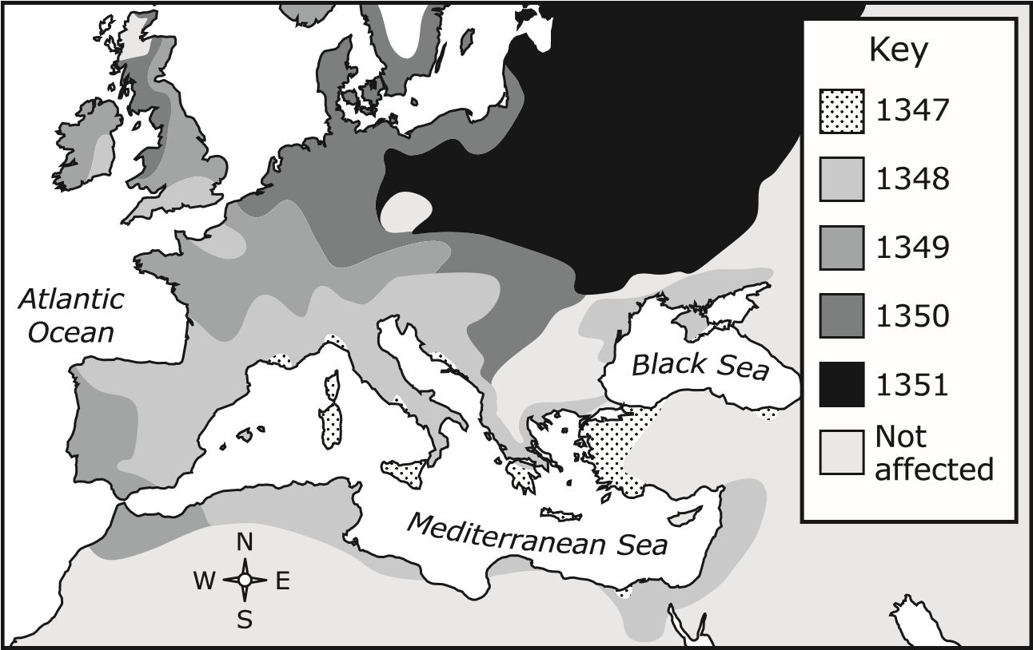

### <http://www.history.com/topics/black-death/videos/the-black-death-begins>

1. Watch the video and describe how the plague diffuse around Europe.
2. How did the development of an interstate highway system change the urban landscape in the United States?

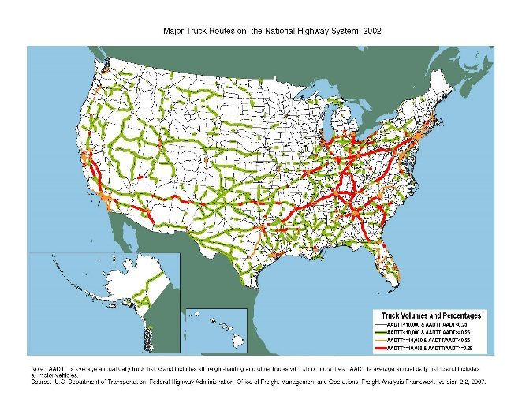

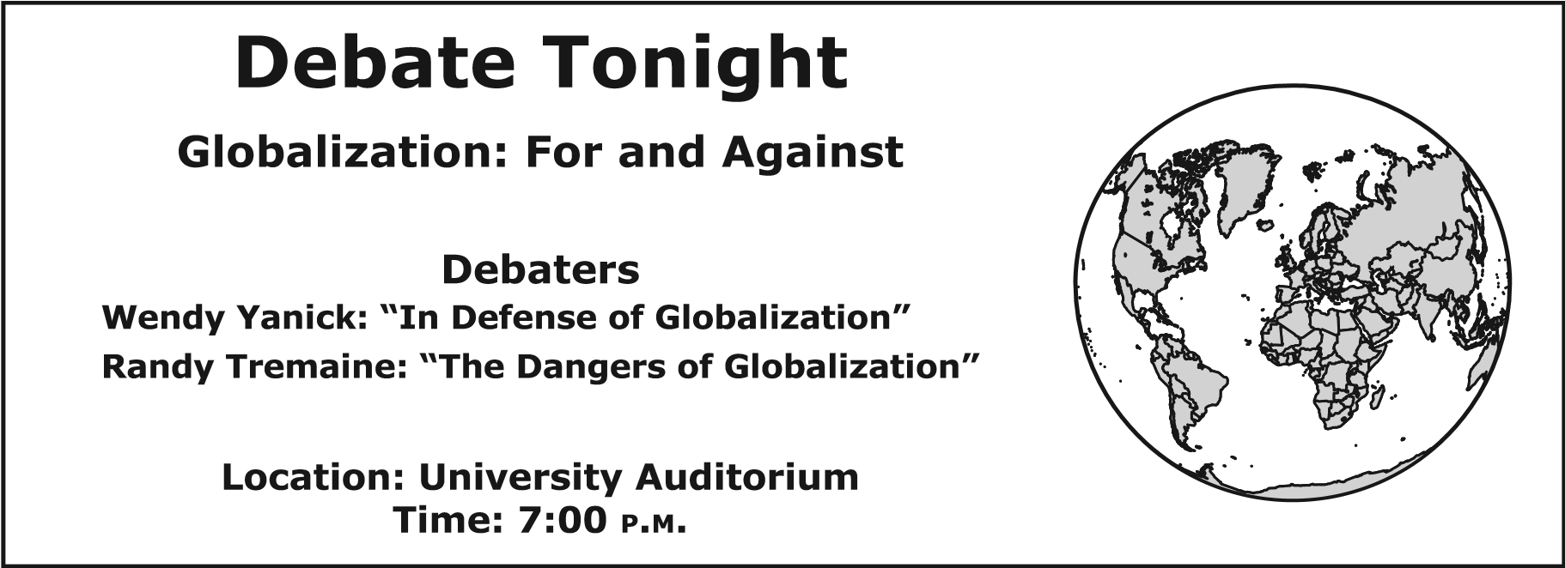

1. Create arguments for Randy Tremaine and for Wendy Yanick.
2. Research at Washington State University has led to the following conclusions:

* Organic farming methods can help reduce the amount of nitrogen draining into the groundwater.
* Conventional farming practices involve the use of synthetic fertilizers, which are the primary source of nitrogen pollution in water systems and the atmosphere.

What’s this means for water security and organic farming?

________________________________________________________________________________________________________________________________________________________________________________________________________________________

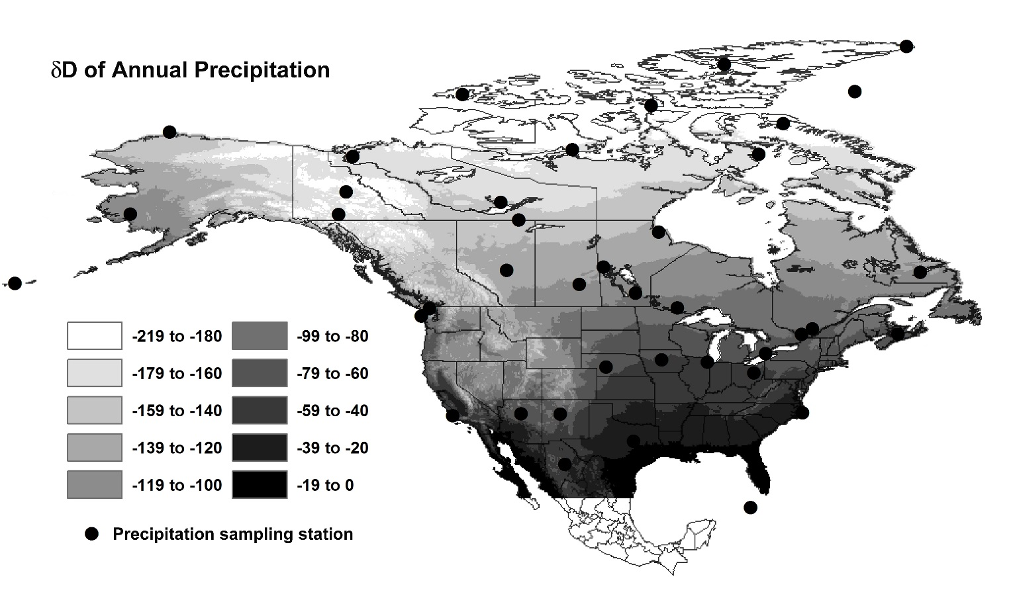

1. Which factor best explains the precipitation distribution of southern United States? Select one and explain why?
2. Latitude
3. Near Water
4. Mountains
5. El Nino

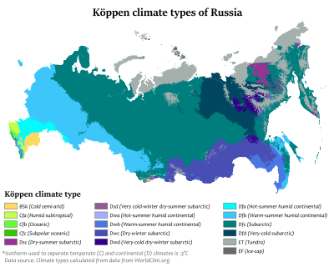

1. Which factor posed the greatest challenge to developing natural resources in Siberia?

It is . . . undeniable that no settlement can be just and complete if recognition is not accorded to the right of the Arab refugee to return to the home from which he has been dislodged by the hazards and strategy of the armed conflict between Arabs and Jews in Palestine.

—Progress Report of the United Nations Mediator on Palestine, 1948

1. What was one reason for the conflict referred to in this report?

______________________________________________________________________________________________________________________________

Satellite Image of Europe at Night

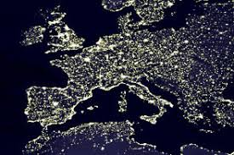

1. Which conclusion is supported by the image about the location of major cities and economic centers?
2. Identify the following locations in the map.

_____ Eastern Indonesia

_____ Eastern part of China

_____Western India

_____ Tibet

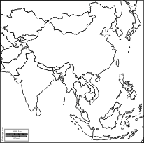

**D**

**C**

**B**

**A**

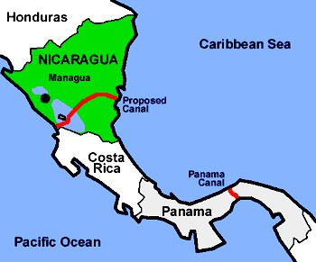

1. The projects showed in the image is an example of how technology and human modifications of the environment can ____________________.
2. List 3 countries that had their religion influenced directly their government.

### Due to its isolationist nature, North Korea’s human rights record is difficult to evaluate. However, non-governmental organizations (NGOs), think tanks, and defectors continue to report that North Korea maintains a record of consistent, severe human rights violations, stemming from the government’s total control over all activity.

### —U.S. Department of State, 2010

### Describe what social and economic activities might be restricted by the North Korean government.

1. Explain how the arrival of Spanish conquerors impacted the culture of Latin America. Provide examples.

Mechanical Dredging: <http://www.shorelinesolutionsbychat.com/what-we-do/hydraulic-mechanical-dredging>

1. What major benefit is associated with this activity?
2. Which of the following is a consequence of the formation of the European Union?
3. More people migrated to western Europe
4. Increased opportunities for trade with Africa
5. The development of new markets in former Soviet countries
6. People migrated to northern Europe

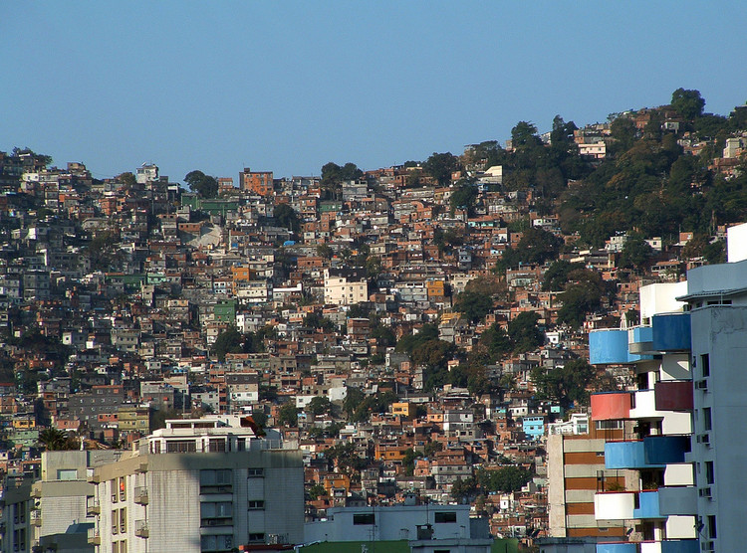

1. What was one reason for the expansion of Brazilian favelas?

______________________________________________________________________________________________________________________________________________________

### • Girls in poor countries with pre-existing low female schooling are highly vulnerable to being pulled out of school as households cope with declining household income.

### • Women’s income in developing countries will likely be reduced as a result of losses in employment in export oriented industries, tightening micro-finance lending, and/or drop in remittances.

### —World Bank press release, March 6, 2009

### What is the primary cause of the situation describe above?

1. What is the most likely result of a well-planned national transportation network? Provide examples.
2. Match the following level of economic activities:

______ Primary A. Research Center

______ Secondary B. Farming

______ Tertiary C. Textile Factory

______ Quaternary D. Amazon Prime

## Average Annual Rate of Population Growth, 1980–1998

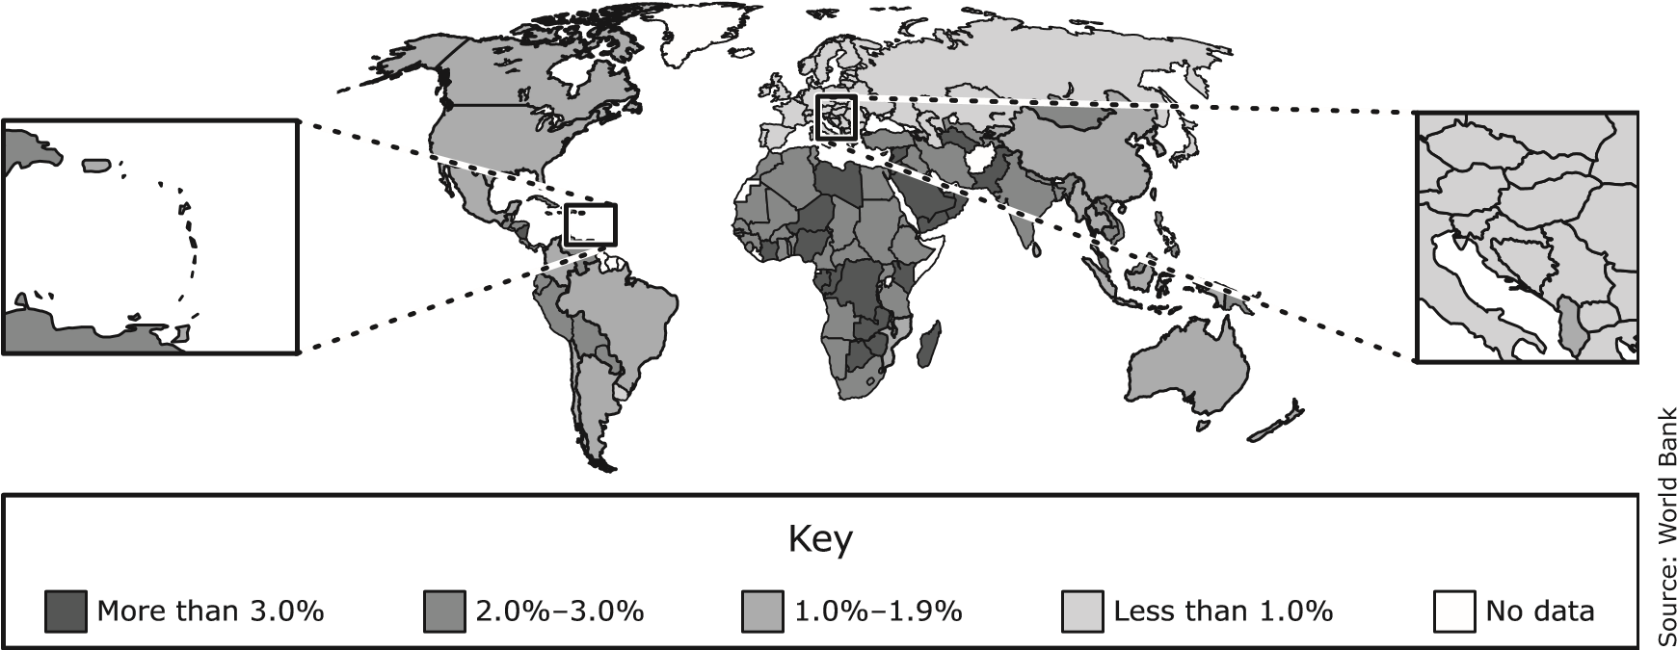

1. Where in the world the population growth was higher from 1980 to 1998? What factors might explain this trend?

Death Valley Rain shadow effect: <https://www.nationalgeographic.org/encyclopedia/rain-shadow/>

1. Describe the processes that take place during the rain Shadow effect.
2. What is the international response to climate change and global warming?

Selected North American

Countries, 1836

Selected North American

Countries, 1821

Selected North American

Countries, 1848

*N*

United States

Mexico

*N*

Republic of Texas

Disputed territory

United States

Mexico

*N*

United States

Mexico

1. Which inference is best supported by these maps?

Hindu Temple in Austin, Texas

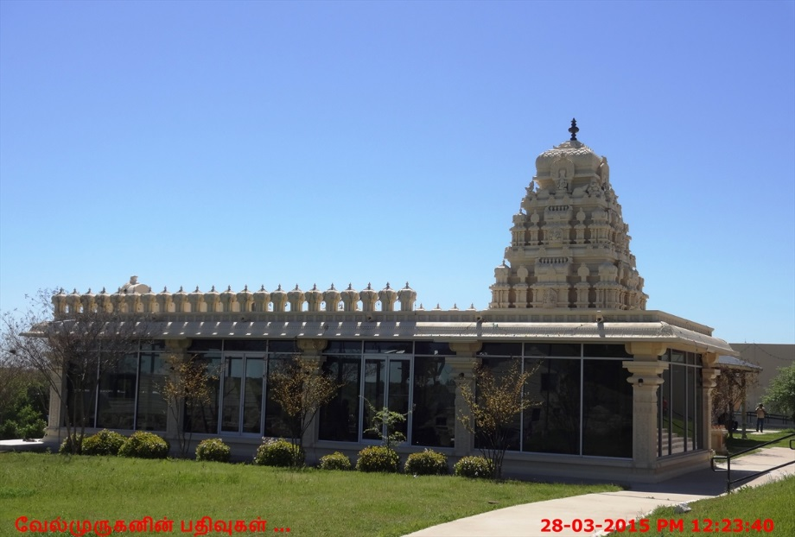

1. What geographic process permitted the above building in Austin?
2. Which challenge of globalization is exposed by the rapid spread of diseases?

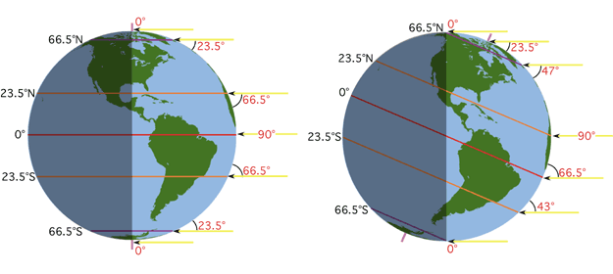

Earth’s Arctic biome is located above 66°N latitude.

1. Why low-growing plants in this biome grow well only in the spring and summer months?

### Cosmopolitan magazine . . . is read by 260,000 Chinese women every month.

### —Erla Zwingler, “A World Together,” National Geographic, August 1999

1. What economic policy influenced China to have the above change?
2. NAFTA
3. free-enterprise
4. Mixed economy
5. Command economy

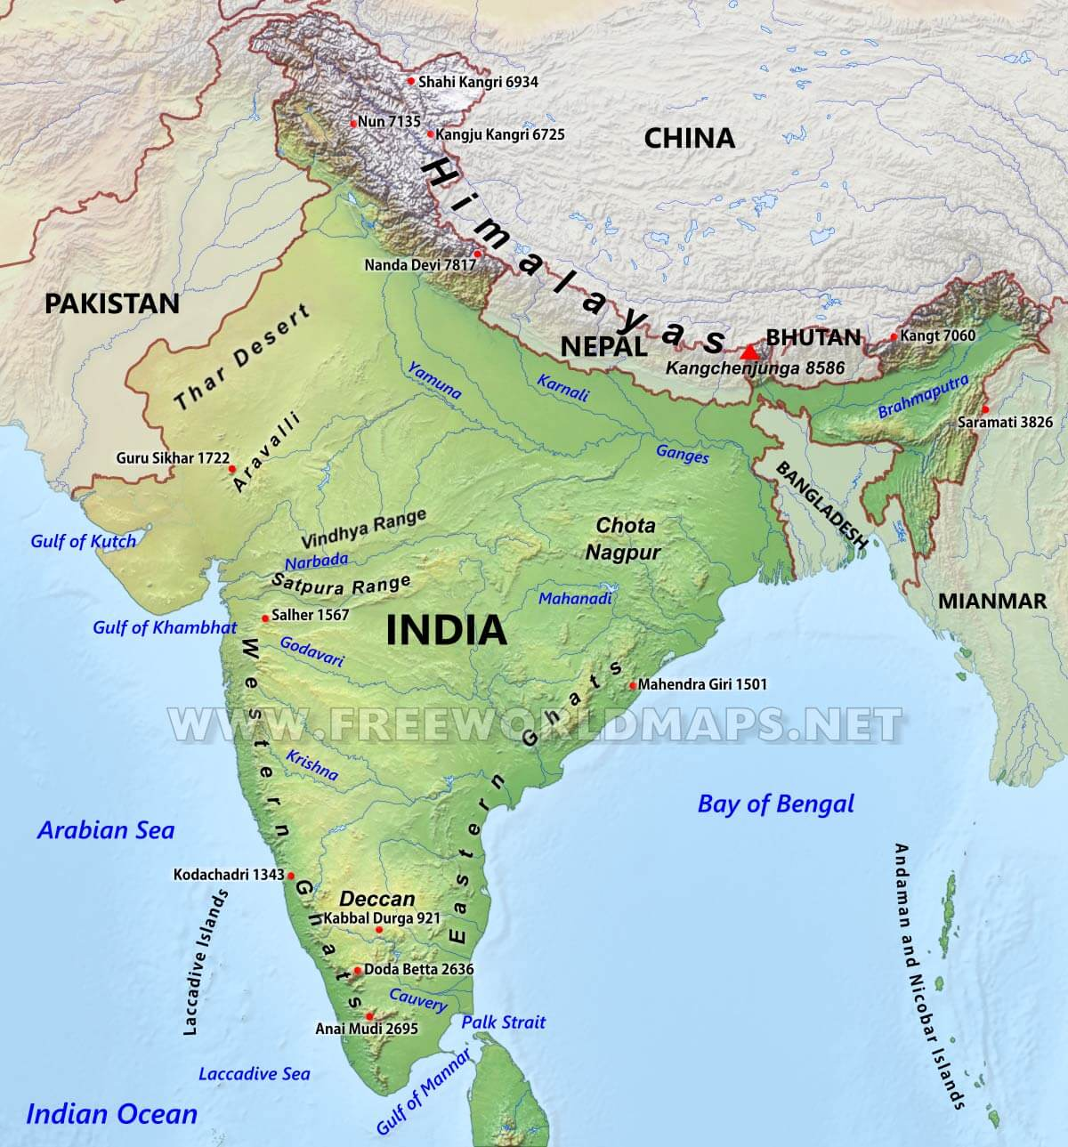

1. Which physical process formed the landform along the northeastern border of India?
2. Which factors have the greatest effect on climate?
3. What was one direct result of the Columbian Exchange?

Average Temperatures in Rome

|  |  |
| --- | --- |
| Month | Daily Average  High Temperature (°C) |
| January | 11 |
| July | 30 |

1. One reason for the difference between these temperatures is —
2. Describes the changes observed in a city or town as a result of the Industrial Revolution? Draw your answer.

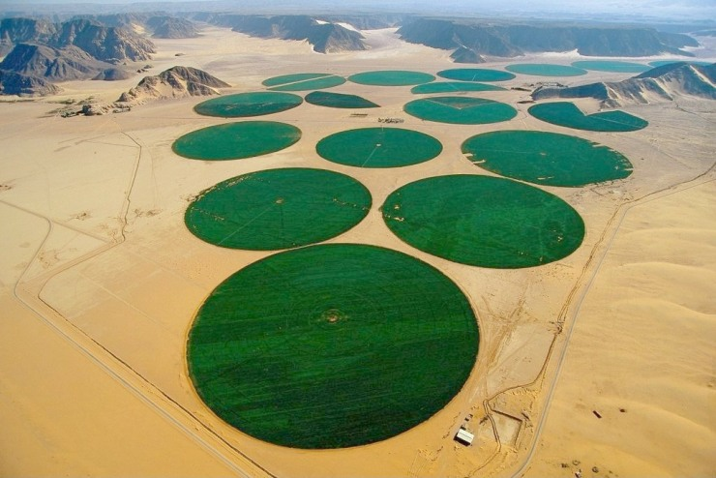

1. What do you think is this? What is the used of this?

**Have a Great Summer!**



**STAAR**

**World Geography**

**May 2013**

**TX546305 1 2 3 4 5 A B C D E Printed in the USA DPSS/ISD6192**