Directions: Please complete the following Fall Final Exam Review: 10 points Bonus for your final score.

- Introduction to Geography

- What is the difference between physical and human geography and how are they related?

- What are regions and what are the types of regions? Define.

● political/formal:
● perceptual/vernacular:
● functional/nodal:

- How does physical geography impact human development?

○ Physical Geography versus Human Geography

Physical Geography | Human Geography
The study of how humans adapt to and are impacted by their physical surroundings. This includes: | The study of how humans change and are impacted by human characteristics creating a cultural landscape. This includes:
Landforms and Bodies of Water | Population, Migration, & Settlement Geography (Demographics
Ocean and Wind currents | Transportation, Urban Patterns, & Social Geography
Spheres: Atmosphere, Hydrosphere, Lithosphere, Biosphere | Developmental Geography
Weather, Climate Regions and Patterns, & Meteorology | Geo-politics and Political Features; Types of Governments
Environmental Geography | Ethnicity and Race
Earth Science, Biomes, Science in Geography | Cultural Geography: Folk & Popular Cultures, Culture Regions, Language, Religion, Cultural Changes
Natural Disasters | Globalization and Industrial Geography
Plate Tectonics | Agriculture and Land Use
Physical Locations | Resource Locations, Distribution, & Resource Issues

- How do Weather patterns, Climates, and Physical Features impact Human Geographic development? Define the following:

■Factors that affect Climate:

.
■Earth-Sun Relationship:

5. How does physical geography impact the way society organizes and adapts to their physical surroundings?

6. What is Location and how does location relate to the way we understand regions? (Define and give examples of each)

■- Absolute Location:
■- Relative Location:
■- Latitude:
■- Longitude:
■- Prime Meridian, what is it? Where is it?
■- What is a topographical (elevation) map?

7. How is the Earth categorized into 4 different “spheres”? Explain each:
■- Hydrosphere
Explain the Water Cycle:

■- Biosphere:

■- Lithosphere:

- Atmosphere:

● Rain Shadow effect (Definition):

Climate and Earth Geographic Phenomenon (Define and give regional examples)
○ Monsoon:
○ Hurricane:
○ Tsunami:
○ El Nino:
○ Seasonal River Flooding

8. Describe what Plate Tectonics and Tectonic forces are:

How do volcanoes and earthquakes relate to Tectonics?
● Fault Lines (Descriptions):
“Ring of Fire” (Description and location):

World Map of Cultural Regions: (Draw & label Continents, Oceans and Megacities)
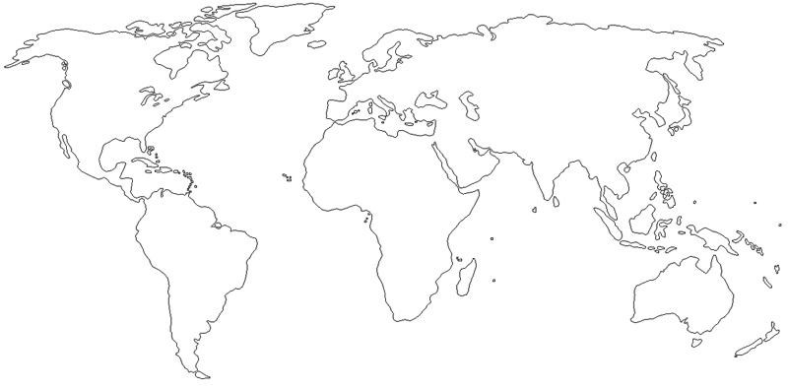

- Population, Migration, and Settlement:

- Where do people tend to live and why?

- How do population patterns cause problems and obstacles for regions and countries?

- How do population patterns create relationships with migration and cultural changes?

Define the following:

  - Demographic transition:
  - Population Clusters:
  - Population Density:
  - Population Pyramids:
  - Census:
  - Refugees

- What are push and pull factors and examples of each?
- Where are people leaving and entering? and Why?

- What are the major “revolutions” that impacted human population growth and when did they happen? Define
- Agricultural Revolution
- Industrial Revolution
  - Medical/Tech Revolution

- Culture: Cultures, Language, Religion, and Ethnicity:

- Where are different regional examples of cultural aspects and how do they impact the landscape?
○ Culture (Define and give regional examples of) ■Customs:
■Habits:
■Taboos
■Materials:
■Institutions:
■Cultural Convergence (come together)
■Cultural Divergence: (separate)
■Cultural Continuity:
■Multiculturalism:
■Relate the connection between diffusion, culture(s), & the physical/cultural landscape ■Diffusion of Democracy:
■Folk Culture:
            - Traditional ways of living
■Popular Culture
            - Diffusion of American Popular culture to other parts of the world
            - Diffusion of other cultural practices into the USA
■Economic, political, and social opportunities in different cultures for:
            - women
            - ethnic minorities
            - religious minorities
            - underrepresented populations
■Education

○ Religions:

2. What are the world’s major religions, where did they originate, how did they diffuse & where to?
■(Be able to define, locate, explain key cultural impacts, major beliefs and current geopolitical and economic issues.)
            - Hinduism (Hindu) - ● Judaism (Jewish) - ● Buddhism (Buddhist) - ● Christianity (Christian) - ● Islam (Muslim) -
            - Sikhism (Sikh) -

- Geo-Politics:

1. How do different groups of people organize their territories, respond to political structures, and claim territory? How does this cause geo-political problems and solutions?

○ Geo-political Terms (know definitions and regional examples of each)
■Territoriality
■Borders and Border Disputes
■Shapes of State Territories
■From ethnicities to nations: (define and give example of each)
            - Nation,
            - State,
            - Nation-State,
            - Stateless Nation
■Supranational Organizations and Other Trading Partners
            - European Union
            - United Nations
            - NATO
            - OPEC
            - NAFTA
○ Types of Governments: Each society chooses and changes their forms of government based on changes of growth, culture, and to arrange their society. (define and give country examples of each type of government). Explain the difficulties and reasons behind each.
■Democracy
            - Pure (Direct) Democracy
            - Representative (Republic) Democracy
■Autocracy
            - Monarchy
            - Dictatorship
            - Totalitarianism
■Oligarchy
            - Theocracy

Geo-political Issues Map: Label important geo-political conflicts, issues, and disputes on the map below:
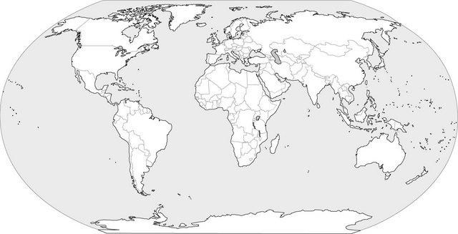

- Development and Economic Geography:

- How do different regions and countries respond to changes in economic relationships, how do they use their resources, and how do they structure their area in a globalized and interconnected world?
Define:
○ Types of Economic Systems:
- Free Enterprise/Market
- Command
- Traditional
- Mixed

Type of Industries:
- Commercial Industry

- Cottage Industry

○ Level of Economic Systems
■Primary
■Secondary
■Tertiary
■Quaternary

○ Ways to Categorize Economic and Industrial Development:
■More Developed Country (MDC)
■Less Developed Country (LDC)
■Newly Industrialized countries/ periphery (like India, China, Mexico, Turkey, Brazil) Define Each:
○ Stages of Development
○ Sustainable Development
○ Human Development Index (HDI)
○ AIDS and Pandemics
○ Uneven Development, Poverty, Wealth: (Give regional examples of poverty and wealth and what determines

How are issues of development measured? Define
  - Gross Domestic Product (GDP) Per Capita
  - Life Expectancy
  - Literacy Rate
  - Infant Mortality

- Agriculture, Land Use, & Urban Patterns: Where are agricultural zones and how do societies organize based on agricultural land use? Why are cities growing and how are they changing due to such growth? Define Each:
  - Urbanization:
○ urban growth
○ urban sprawl
  - City Structure
○ Urban Core (CBD)
○ Suburbs
○ Rural area
  - Climate, Soil types, and location: how is this important when determining city location
  - History and Agriculture:
○ Columbian Exchange
  - Subsistence Agriculture vs. Commercial Agriculture
  - Agriculture and Development: How is a country’s level of development related to agricultural (and industrial output)?
  - From Nomadic Lifestyle to Agrarian society to industrialized society
  - Examples of Agricultural issues today: ○ Population growth
○ Famine (related to geo-political)
○ Organic
○ GMOs
○ Green Revolution

- Resource and Environmental Issues: Where are the world’s resources located and how do humans adapt to resource needs? Define Each:
○ Natural Resources: (Define and give an example of)
○ Resource Scarcity and Resource Management
○ Renewable resource
■Example 1:
■Example 2:
○ Non-renewable resource:
■Example 1:
■Example 2:

      - Environmental Issues
      - Air Pollution
      - Water Pollution

- Globalization: How and why is the world more connected today and how does that impact politics, economics, and cultures?

○ Technological impacts of Globalization: How have technological inventions changed our interconnectivity in a positive and negative way?

○ Cultural Impacts of Globalization: How do cultures change based on increased globalized patterns? Provide examples:

○ Information and Technology: Outsorcing
■India
■USA
■China

Extra For You:

- Social Studies (Geographic) Skills: What are the important skills related to social studies and how are they used?
  - Reading Comprehension, inference, understanding, and analyzing
  - Citizenship: How are issues of geography, politics, history, and economics related to our responsibilities as citizens?
  - Social Studies:
○ Primary and Secondary Sources
○ Political Cartoons
○ Bias and Point of View
○ GPS and GIS
  - Map, Graphs, Charts, and Diagram Skills:
○ Locate places of contemporary geo-political significances on a map
■Cultural Regions
■Religious and Language Groups
■Geo-political relationships
○ Interpret different types of maps
■answer geographic questions
■infer relationships
■analyze change
■understand relationships between natural and human-made boundaries
  - Vocabulary Application: Apply physical geographic terms to various regions of the world
  - Vocabulary Application: Apply conceptual and human geographic terms to various regions of the world.
  - Problem-solving & decision-making: ○ identify a problem,
○ list and consider options,
○ consider advantages and disadvantages,
○ choose and implement a solution,
○ evaluate the effectiveness of the solution

